***Python installation:***

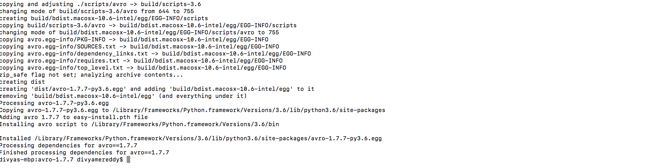

***Installed hexdump and avro using PIP:***

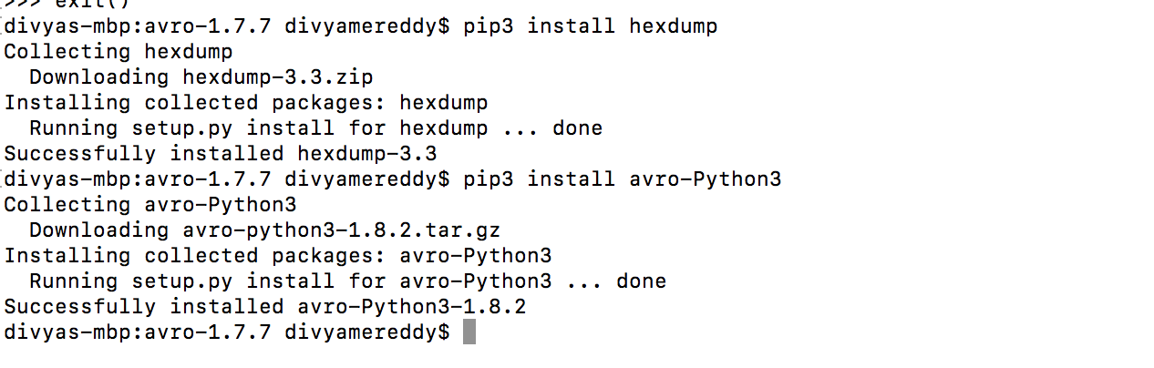



***Code:***

import avro.schema

from avro.datafile import DataFileReader, DataFileWriter

from avro.io import DatumReader, DatumWriter

schema = avro.schema.Parse(open("/Users/divyamereddy/user.avsc").read())

writer = DataFileWriter(open("/Users/divyamereddy/users.avro", "wb"), DatumWriter(), schema)

writer.append({"name": "Alyssa", "favorite_number": 256})

writer.append({"name": "Ben", "favorite_number": 7, "favorite_color": "red"})

writer.close()

#Deserialization:

reader = DataFileReader(open("/Users/divyamereddy/users.avro", "rb"), DatumReader())

for user in reader:

print (user)

reader.close()

***Serializing:***

***After running output file is created:***

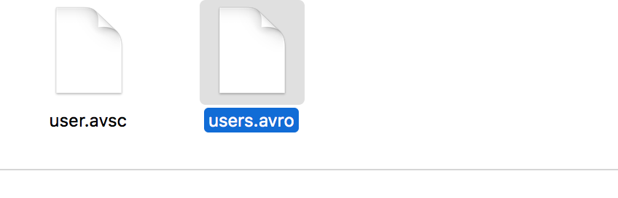

***Data in User.avro:***

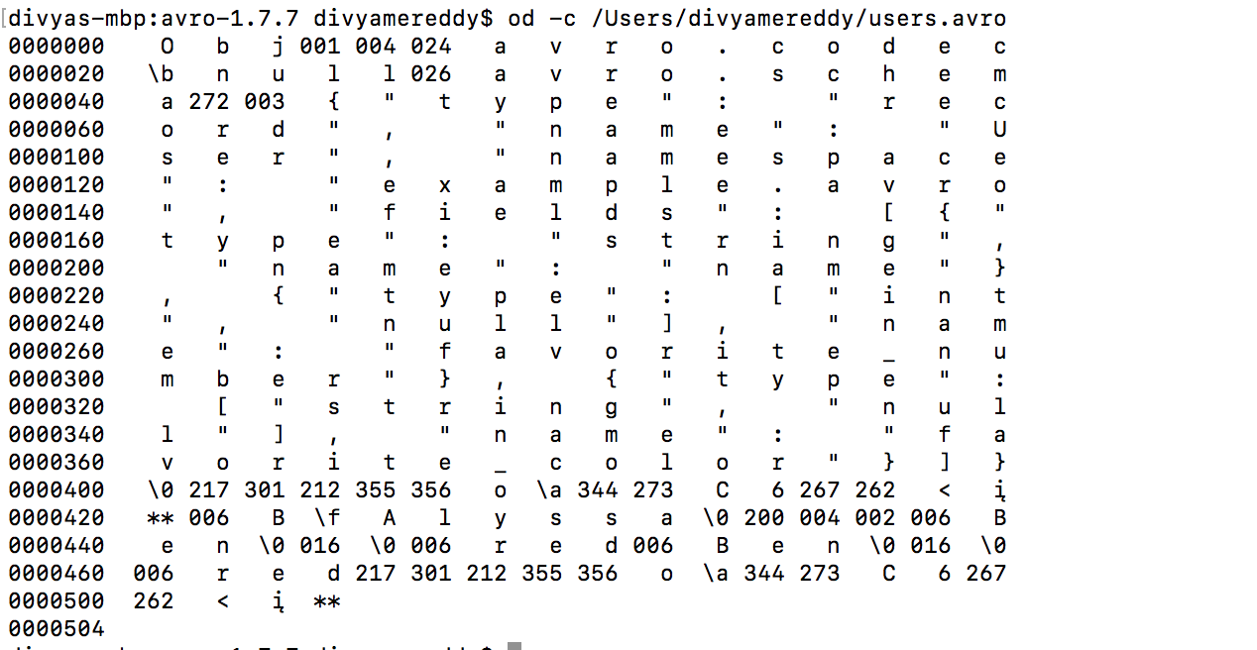

***Deserialization:***

